Cash Receipt Checklist

The Cash Receipt tab is used to record cash receipts (monies received) or deposits for all district accounts that are valid in the chart of accounts.

Receipts can be numbered manually or automatically. To set up Auto Numbering, select the box to Use Automatic Cash Receipt Number Assignment from Finance > Tables > District Finance Options and enter the number below that you wish Ascender to begin using.

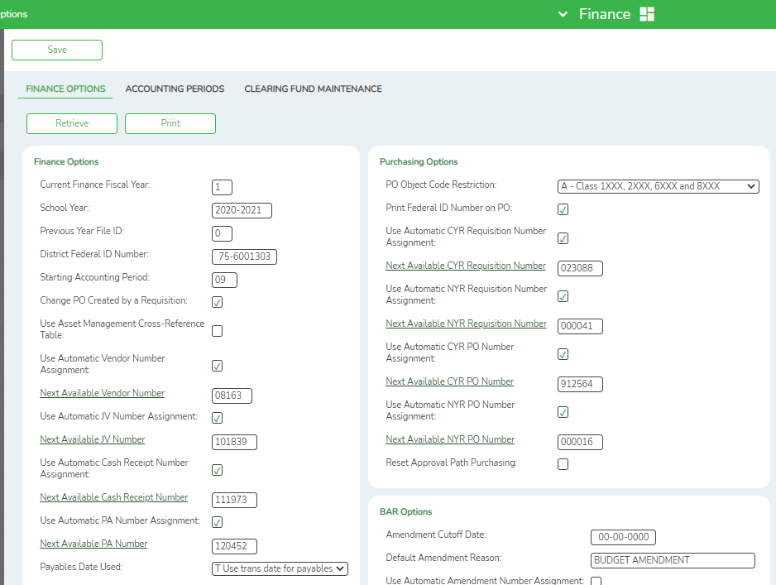

Add or edit existing Cash Receipts from Finance > Maintenance > Postings > Cash Receipt.

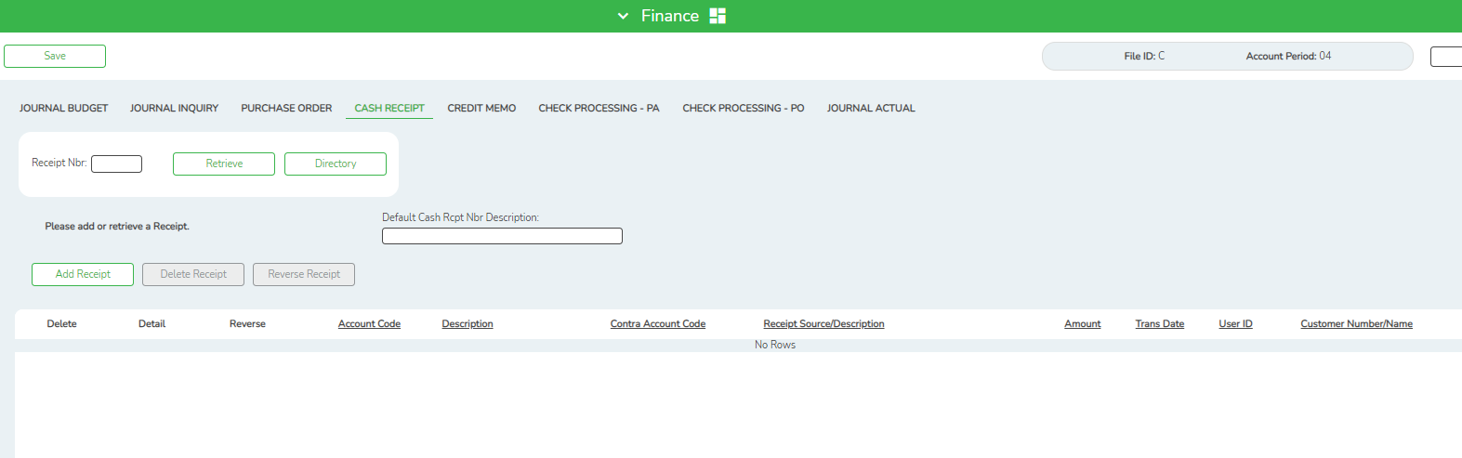

To retrieve existing cash receipts:

In the Receipt Nbr field, type a receipt number, if known, and then click Retrieve. The cash receipts are displayed.

● If the receipt number is not known, click Directory.
● To search for a specific item, type data in the desired search fields.
● To search through all available data, leave all fields blank.
● Click Search.
● A list of data that matches the search criteria is displayed.
● Select an item from the list. Otherwise, click Cancel.
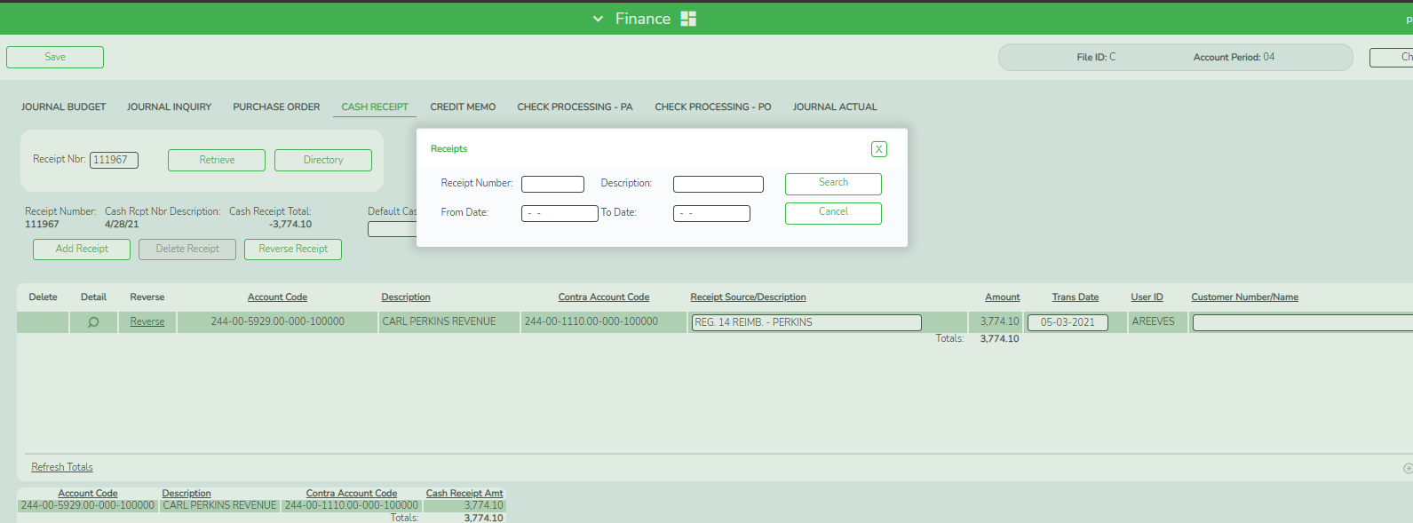

Note: The Retrieve button is also used to retrieve information from the last save. If you click Retrieve, any unsaved changes are lost.

To add a cash receipt:

- To add a new cash receipt, click Add Receipt.
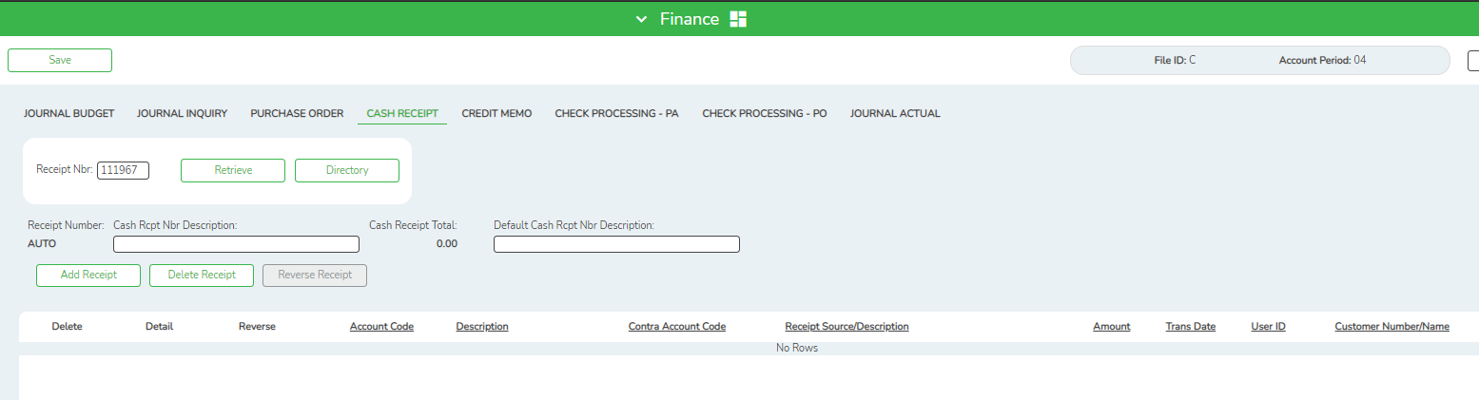

- In the Cash Rcpt Nbr Description field, type a description of the cash receipt. The description can be a maximum of 30 characters and is displayed on the FIN1000 - Cash Receipt Journal report.

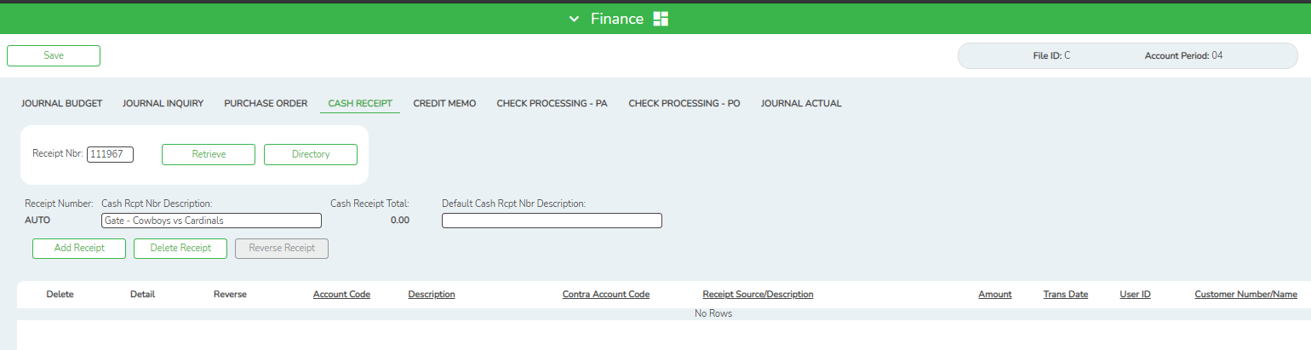

- In the Cash Receipt Total field, the system displays the total cash receipt transactions entered in the detail section. The field is display only.

- Optional: In the Default Cash Rcpt Nbr Description field, type a cash receipt number description that is automatically used for new cash receipts, that is, all cash receipts created contain the default reason.

- To delete a cash receipt, click Delete Receipt.

- To reverse a cash receipt, click Reverse Receipt.

- In the transaction section, click +Add, or press ALT+1 to add row(s). Continue adding rows as needed.

- In the Account Code field, begin typing the desired account code. A list of account codes fitting the parameters of the info entered is displayed. Click on the desired account code. Alternatively, you may click on the ellipsis to the right of the account code field to allow a search directory. The Description and Contra Account Code fields are populated by the system. The system automatically is set to a contra account.

NOTE: The Contra Account will automatically default to the same fund number and fiscal year as the account number. The object code is determined by the Finance Automatic Posting Defaults section of the Clearing Fund Maintenance tab on the District Finance Options page. If needed, you may manually edit a contra account code, however, the function code must be 00, and the object code must be 11XX, 181X, or 191X.

- The Receipt Source/Description field will default to the description previously entered, but can be edited.

- In the Amount field, type the amount of the cash receipt. The value is also entered in the transaction and summary sections as display only. As additional detail transactions are entered in the detail section, the cash receipt amount displayed in the transaction and summary sections update to include each additional transaction.

- The Trans (Transaction) Date field is set to the current system date, but it can be modified. If the Trans Date field is modified, all new transactions default to the last transaction date that was entered.

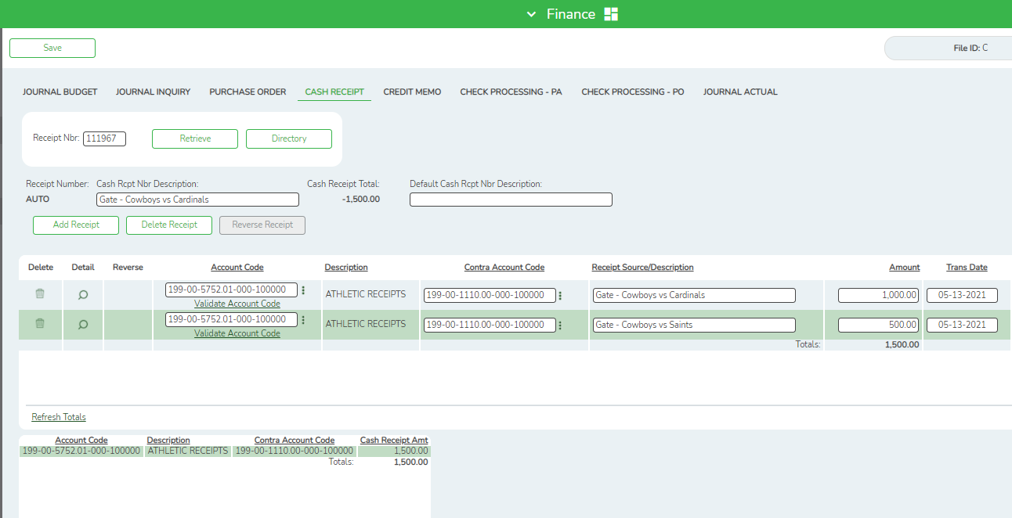

- The User ID field displays the name of the user who created the transaction. Users are created in the Security Administration application. The field is display only.

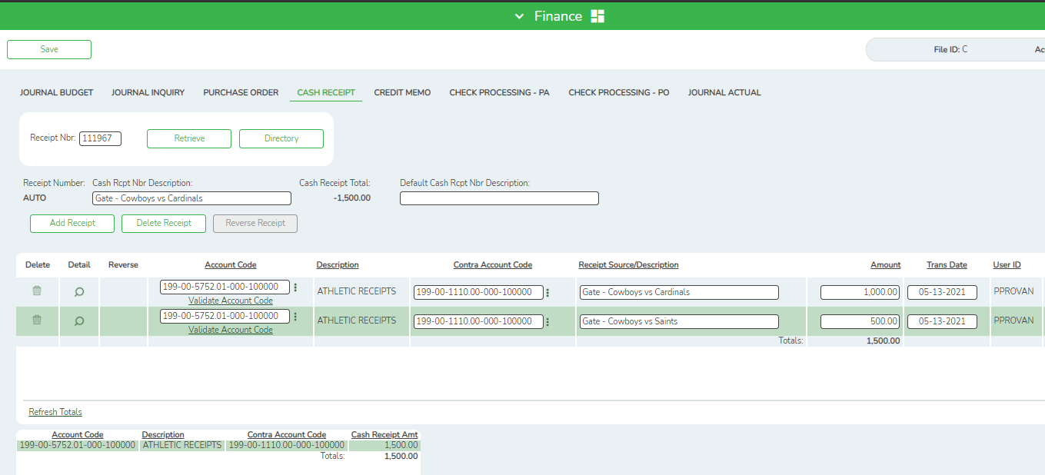

- To add another row, click +Add, or press ALT+1. Continue adding detail account transactions as needed until the Total field has reached the amount of the cash receipt.

Note: We recommend your cash receipt matches exactly each deposit made to the bank to make bank reconciliation easier. For example, if you made two separate deposits for the lunch room in the same day, do not combine those when entering cash receipts. Your bank statement will show 2 separate deposits. Your bank reconciliation should show two separate cash receipts.

- Click Save to save the changes.

- To delete a row, click the trash can icon to the left of the desired row. The row is shaded red to indicate that it will be deleted when the record is saved.

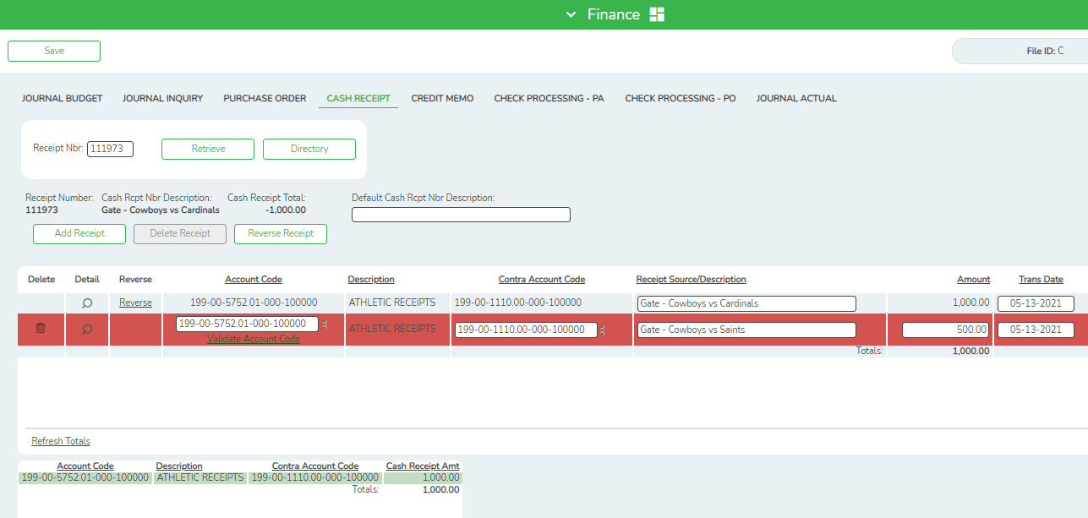

- You can reverse it by selecting the Reverse Receipt.

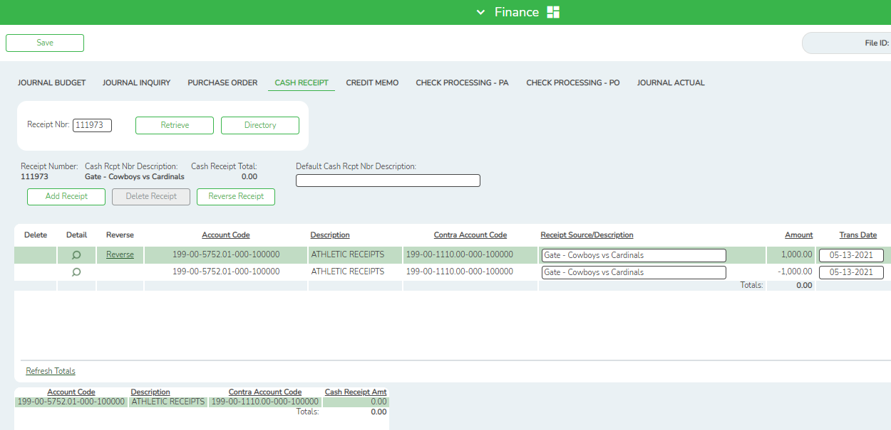

- The Account Code, Description, Contra Account Code, and Cash Receipt Amt fields are populated by the entries in the detail (middle) section.

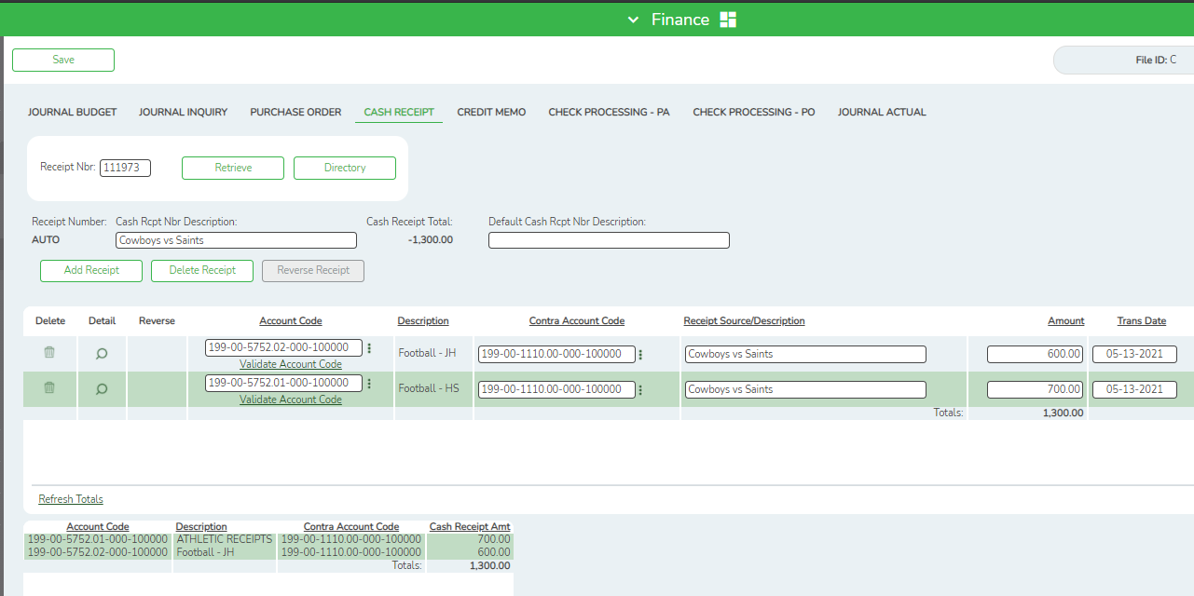

- Click Save in the upper left corner to save the changes.

- Click Refresh Totals to update the totals if any amounts are changed in the grid.

- The user can reverse a cash receipt in either the transaction or detail section of the tab.

Reversing Cash Receipts

- The user can Reverse the entire Receipt if it has been saved incorrectly by clicking the Reverse Receipt button. (See step 16)
- Alternatively, users can Reverse individual lines by clicking the Reverse link to the left of the desired line, and the resulting reversal entries are displayed in the detail section.

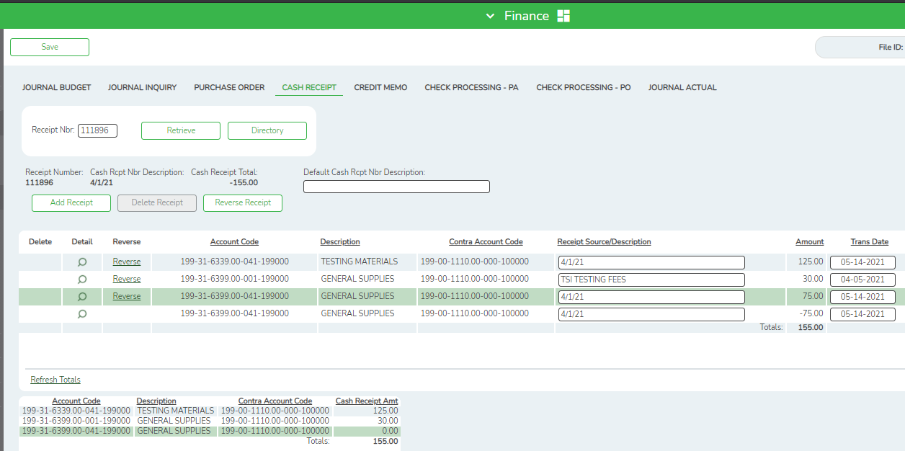

- If the user has not saved the reversal, Reverse cannot be clicked.
- However, once the reversal is saved, the user can again select Reverse, and it reverses all transactions residing in the detail section for that line item. The summary section still displays as zero amounts. Once saved, all entries in the detail section are displayed on the general ledger.

